Marketing Research

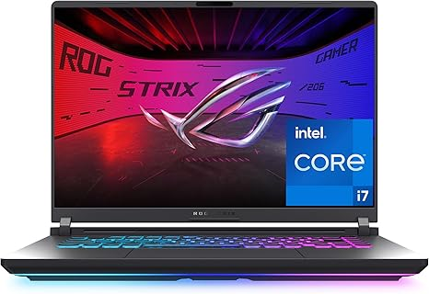

ASUS ROG Strix G16 (2025) Gaming Laptop, 16” FHD+ 16:10 165Hz/3ms Display, NVIDIA® GeForce RTX™ 5060 Laptop GPU, Intel® Core™ i7 Processor 14650HX, 16GB DDR5, 1TB Gen 4 SSD, Wi-Fi 7, Windows 11 Home

LKR444,206.68

Brand | ASUS
Model Name | ROG Strix G16
Screen Size | 16 Inches
Color | Eclipse Gray
Hard Disk Size | 1 TB
CPU Model | Core i7
Ram Memory Installed Size | 16 GB
Operating System | Windows 11 Home
Special Feature | ROG Nebula Display, Tri-Fan Technology
Graphics Card Description | Dedicated

About this item
- HIGH-LEVEL PERFORMANCE – Unleash power with Windows 11 Home, an Intel Core i7 Processor 14650HX, and an NVIDIA GeForce RTX 5060 Laptop GPU powered by the NVIDIA Blackwell architecture and featuring DLSS 4 and Max-Q technologies.
- FAST MEMORY AND STORAGE – Multitask seamlessly with 16GB of DDR5-5600MHz memory and store all your game library on 1TB of PCIe Gen 4 SSD.
- DYNAMIC DISPLAY AND SMOOTH VISUALS – Immerse yourself in stunning visuals with the smooth 165Hz FHD+ display for gaming, creation, and entertainment. Featuring a new ACR film that enhances contrast and reduces glare.
- STATE-OF-THE-ART ROG INTELLIGENT COOLING – ROG’s advanced thermals keep your system cool, quiet and comfortable. State of the art cooling equals best in class performance. Featuring an end-to-end vapor chamber, tri-fan technology and Conductonaut extreme liquid metal applied to the chipset delivers fast gameplay.
- FULL-SURROUND RGB LIGHTBAR, YOUR WAY – Showcase your style with a 360° RGB light bar that syncs with your keyboard and ROG peripherals. In professional settings, Stealth Mode turns off all lighting for a sleek, refined look.

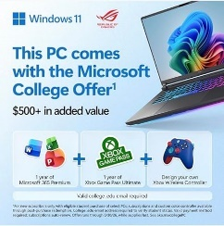 \
https://www.amazon.com/ASUS-ROG-Strix-Gaming-Laptop/dp/B0DZZWMB2L/ref=sr_1_5?_encoding=UTF8&content-id=amzn1.sym.bd749ccd-05a5-46df-9094-58bcc6398482&dib=eyJ2IjoiMSJ9.sa4bsFUOsBKNESVUhrqkbAxlAO-oDE4cltkKVKltfX4G-vSAFr6WvWS3zT0bRfLZ3U4HM_HkYpl7Vm1yfzOw9pdSGjNepcTtc1DbGE6WS6XX6VOPdag3yf5aVMs06X9KZsZNXXjAb2dJuA3QWVFkiZL7p_ZcuAO9ct3tj8wtuuhVtW20FiBFrtR78F_cWTWxU7E0fMF7t4HQtSJHzb-Eq3u6wxmUe3VzWoQzGmVeY0jMyXpycqvADlAsFb__0Gh0XpFTkK2DvSEjx_GM4UPW-gQLKJvKdIHu6RVrT5eM5xQ.72fIWXo60muT-ZXAcaG0munFGp1XNTPh_B6wgWFuByw&dib_tag=se&keywords=gaming&pd_rd_r=f82d9443-5a90-439c-b846-744beff13a8f&pd_rd_w=uabdx&pd_rd_wg=4yi79&qid=1780381516&sr=8-5&th=1

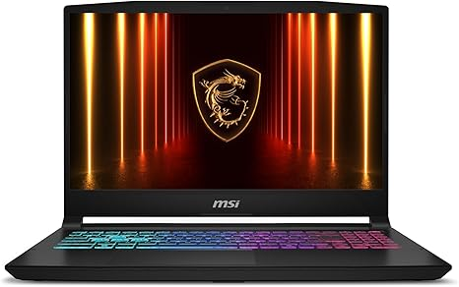
msi Katana 15 HX 15.6” 165Hz QHD+ Gaming Laptop: Intel Core i9-14900HX, NVIDIA Geforce RTX 5070, 32GB DDR5, 1TB NVMe SSD, RGB Keyboard, Win 11 Home: Black B14WGK-016US
4.1 4.1 out of 5 stars (314)
Amazon's Choice
This item cannot be shipped to your selected delivery location. Please choose a different delivery location.
Style: 14th Gen i9
- 14th Gen i9.
- 14th Gen i7

See available options
Pattern: RTX 5070
- RTX 5060
- RTX 5070
Set: 32GB
- 16GB
- 32GB
Capacity: 1TB
Brand | msi
Model Name | Katana 15 HX B14WGK-016US
Screen Size | 15.6 Inches
Color | Black
Hard Disk Size | 1 TB
CPU Model | Core i9
Ram Memory Installed Size | 32 GB
Operating System | Windows 11 Home
Special Feature | Backlit Keyboard, HD Audio
Graphics Card Description | RTX 5070
See more
About this item
- Intel Core i9 HX Power for Elite Gaming: Dominate demanding titles with the Intel Core i9-14900HX and its 24-core hybrid architecture, delivering fast load times, high FPS, and smooth multitasking.
- GeForce RTX 5070 With Ray Tracing & DLSS 4: Powered by NVIDIA Blackwell, the RTX 5070 delivers stronger ray tracing, higher FPS, faster AI upscaling, and more responsive gameplay—ideal for competitive and cinematic gaming.
- QHD 165Hz, 100% DCI-P3 for Ultra-Clear Combat: The QHD 165Hz display reveals more detail, reduces motion blur, and boosts visibility in fast-paced games while delivering richer, more accurate colors.
- Cooler Boost 5 for Sustained Performance: Dual fans and a 5-heat-pipe share-pipe design keep the CPU and GPU cool, maintaining stable frame rates during long gaming marathons.
- 4-Zone RGB Keyboard + Full Game-Ready Ports: Customize your setup with a 4-zone RGB keyboard and highlighted WASD keys. Includes USB-C Gen 2, HDMI up to 8K, multiple USB-A ports, RJ45, Wi-Fi 6E & Hi-Res Audio.
https://www.amazon.com/Katana-15-6-165Hz-Gaming-Laptop/dp/B0DZFVBQLK/ref=sr_1_1_sspa?_encoding=UTF8&content-id=amzn1.sym.bd749ccd-05a5-46df-9094-58bcc6398482&dib=eyJ2IjoiMSJ9.sa4bsFUOsBKNESVUhrqkbAxlAO-oDE4cltkKVKltfX4G-vSAFr6WvWS3zT0bRfLZ3U4HM_HkYpl7Vm1yfzOw9pdSGjNepcTtc1DbGE6WS6XX6VOPdag3yf5aVMs06X9KZsZNXXjAb2dJuA3QWVFkiZL7p_ZcuAO9ct3tj8wtuuhVtW20FiBFrtR78F_cWTWxU7E0fMF7t4HQtSJHzb-Eq3u6wxmUe3VzWoQzGmVeY0jMyXpycqvADlAsFb__0Gh0XpFTkK2DvSEjx_GM4UPW-gQLKJvKdIHu6RVrT5eM5xQ.72fIWXo60muT-ZXAcaG0munFGp1XNTPh_B6wgWFuByw&dib_tag=se&keywords=gaming&pd_rd_r=f82d9443-5a90-439c-b846-744beff13a8f&pd_rd_w=uabdx&pd_rd_wg=4yi79&qid=1780381516&sr=8-1-spons&sp_csd=d2lkZ2V0TmFtZT1zcF9hdGY&th=1


ASUS ROG Strix G16 (2025) Gaming Laptop, 16” ROG Nebula Display 16:10 2.5K 240Hz/3ms, NVIDIA® GeForce RTX™ 5070 Ti GPU, Intel® Core™ Ultra 9 275HX Processor, 32GB DDR5, 1TB SSD, Wi-Fi 7, Win11 Home
4.4 4.4 out of 5 stars (170)
Amazon's Choice
50+ bought in past month

LKR 859,519.83LKR859,519.83
LKR 282,378.33 Shipping & Import Charges to Sri Lanka Details
Savings Get 1 Month of Xbox GamePass for new users Shop items
Savings 007 First Light With Select GeForce RTX 50 Shop items
Savings Intel® Spring Game Bundle Shop items
Available at a lower price from other sellers that may not offer free Prime shipping.
Style: RTX 5070 Ti
- RTX 5070 Ti
See more

About this item
- CUTTING-EDGE PERFORMANCE – Experience next-level performance with Windows 11 Home, an Intel Core Ultra 9 275HX Processor, and an NVIDIA GeForce RTX 5070 Ti Laptop GPU powered by the NVIDIA Blackwell architecture and featuring DLSS 4 and Max-Q technologies.
- HIGH-PERFORMANCE MEMORY AND STORAGE – Multitask seamlessly with 32GB of DDR5-5600MHz memory and store your game library on 1TB of PCIe Gen 4 SSD.
- PREMIUM ROG NEBULA DISPLAY – Immerse yourself in stunning visuals with the ultra-fast 240Hz/3ms display ideal for gaming, creation, and entertainment. Featuring a new ACR film that enhances contrast and reduces glare.
- STATE-OF-THE-ART ROG INTELLIGENT COOLING – ROG’s advanced thermals keep your system cool, quiet and comfortable. State of the art cooling equals best in class performance. Featuring an end-to-end vapor chamber, tri-fan technology and Conductonaut extreme liquid metal applied to the chipset delivers fast gameplay.
- CUSTOMIZABLE FULL-SURROUND RGB LIGHTBAR – Showcase your style with a full-surround RGB light bar that syncs with your keyboard and ROG peripherals. In professional settings, Stealth Mode turns off all lighting for a sleek, refined look.
https://www.amazon.com/ASUS-Gaming-Laptop-Nebula-Display/dp/B0DW1X5YCQ/ref=sr_1_13?_encoding=UTF8&content-id=amzn1.sym.bd749ccd-05a5-46df-9094-58bcc6398482&dib=eyJ2IjoiMSJ9.sa4bsFUOsBKNESVUhrqkbAxlAO-oDE4cltkKVKltfX4G-vSAFr6WvWS3zT0bRfLZ3U4HM_HkYpl7Vm1yfzOw9pdSGjNepcTtc1DbGE6WS6XX6VOPdag3yf5aVMs06X9KZsZNXXjAb2dJuA3QWVFkiZL7p_ZcuAO9ct3tj8wtuuhVtW20FiBFrtR78F_cWTWxU7E0fMF7t4HQtSJHzb-Eq3u6wxmUe3VzWoQzGmVeY0jMyXpycqvADlAsFb__0Gh0XpFTkK2DvSEjx_GM4UPW-gQLKJvKdIHu6RVrT5eM5xQ.72fIWXo60muT-ZXAcaG0munFGp1XNTPh_B6wgWFuByw&dib_tag=se&keywords=gaming&pd_rd_r=f82d9443-5a90-439c-b846-744beff13a8f&pd_rd_w=uabdx&pd_rd_wg=4yi79&qid=1780381516&sr=8-13&th=1

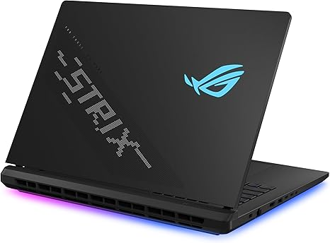
ASUS ROG Strix SCAR 18 (2025) Gaming Laptop, 18” ROG Nebula HDR 16:10 2.5K 240Hz/3ms, NVIDIA® GeForce RTX™ 5080, Intel® Core™ Ultra 9 275HX, 32GB DDR5-5600, 2TB PCIe Gen 4 SSD, Wi-Fi 7, Windows 11 Pro
4.2 4.2 out of 5 stars (286)

LKR 1,079,029.18LKR1,079,029.18
See 1 options with no featured offers
Brand | ASUS
Model Name | ROG Strix SCAR 18
Screen Size | 18 Inches
Color | Off Black
Hard Disk Size | 2 TB
CPU Model | Intel Core Ultra 9
Ram Memory Installed Size | 32 GB
Operating System | Windows 11 Pro
Special Feature | RGB Fans
Graphics Card Description | Dedicated
See more

About this item
- BEST-IN-CLASS PERFORMANCE – Achieve unrivaled performance with Windows 11 Pro an Intel Core Ultra 9 275HX processor, and an NVIDIA GeForce RTX 5080 Laptop GPU.
- HIGH-PERFORMANCE MEMORY AND STORAGE – Multitask seamlessly with 32GB of DDR5-5600MHz memory and store all your game library on 2TB of PCIe Gen 4 SSD, with raw throughput up to 7,000MB/s.
- TOP-TIER ROG NEBULA HDR DISPLAY – Experience breathtaking visuals for gaming, creating, and entertainment, with Mini LED technology, 2,000+ dimming zones, dual ACR layers, a 240Hz refresh rate, and 100% DCI-P3 color for vibrant, lifelike imagery.
- STATE-OF-THE-ART ROG INTELLIGENT COOLING – ROG’s advanced thermals keep your system cool, quiet and comfortable. State of the art cooling equals best in class performance. Featuring an end-to-end vapor chamber, tri-fan technology and Conductonaut extreme liquid metal applied to the chipset delivers fast gameplay.
- SHOW OFF YOUR STYLE – Express yourself with the customizable AniMe Vision, showcasing text, animations, or your own creations on the lid of your laptop. The full-surround RGB light bar creates a striking 360° glow, while Stealth Mode turns off all lighting for a sleek, professional look around the base.
- Edit suggestion: UPGRADE WITH TOOL-FREE ACCESS - Forget about a screwdriver, and customize RAM, SSD, and fans by sliding a latch on the bottom half of the device. A removable frame protects other hardware and offers deeper access for advanced users.
- MUX SWITCH WITH ADVANCED OPTIMUS – A MUX Switch boosts gaming performance by 5-10% by routing frames directly from the dGPU. Advanced Optimus improves battery life by automatically switching between the iGPU and dGPU depending on the task, without restarting.
- 3-MONTH PC GAME PASS INCLUDED – Enjoy a free 3-month pass and access over 100 high-quality games. With new games added regularly, there’s always something fresh to play.
› See more product details
https://www.amazon.com/ASUS-Strix-Gaming-Laptop-Nebula/dp/B0DW29H85Z/ref=sr_1_12?_encoding=UTF8&content-id=amzn1.sym.bd749ccd-05a5-46df-9094-58bcc6398482&dib=eyJ2IjoiMSJ9.sa4bsFUOsBKNESVUhrqkbAxlAO-oDE4cltkKVKltfX4G-vSAFr6WvWS3zT0bRfLZ3U4HM_HkYpl7Vm1yfzOw9pdSGjNepcTtc1DbGE6WS6XX6VOPdag3yf5aVMs06X9KZsZNXXjAb2dJuA3QWVFkiZL7p_ZcuAO9ct3tj8wtuuhVtW20FiBFrtR78F_cWTWxU7E0fMF7t4HQtSJHzb-Eq3u6wxmUe3VzWoQzGmVeY0jMyXpycqvADlAsFb__0Gh0XpFTkK2DvSEjx_GM4UPW-gQLKJvKdIHu6RVrT5eM5xQ.72fIWXo60muT-ZXAcaG0munFGp1XNTPh_B6wgWFuByw&dib_tag=se&keywords=gaming&pd_rd_r=f82d9443-5a90-439c-b846-744beff13a8f&pd_rd_w=uabdx&pd_rd_wg=4yi79&qid=1780381516&sr=8-12&th=1

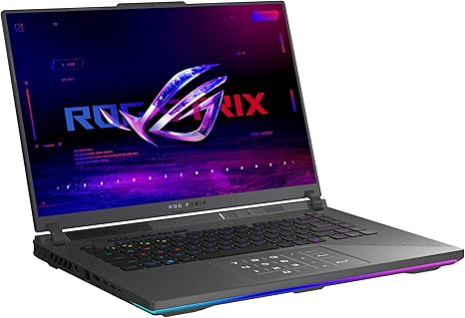
ASUS ROG Strix G16 (2025) Gaming Laptop, 16” ROG Nebula 16:10 2.5K 240Hz/3ms, NVIDIA® GeForce RTX™ 5070 Ti, AMD Ryzen™ 9 9955HX3D Processor, 32GB DDR5-5600, 1TB PCIe Gen 4 SSD, Wi-Fi 6E, Win 11 Home
4.8 4.8 out of 5 stars (13)

LKR 762,446.68 with 8 percent savings-8% LKR762,446.68
Savings 007 First Light With Select GeForce RTX 50 Shop items
Available at a lower price from other sellers that may not offer free Prime shipping.
Style: R9 X3D | RTX5070 Ti
- R9 X3D | RTX5070 Ti

LKR 762,446.68 with 8 percent savingsLKR762,446.68
LKR828,746.68
See 1 options with no featured offers
Brand | ASUS
Model Name | G614FR-DS96
Screen Size | 16 Inches
Color | Eclipse Gray
Hard Disk Size | 1 TB
CPU Model | Ryzen 9
Ram Memory Installed Size | 32 GB
Operating System | Windows 11 Home
Special Feature | Backlit Keyboard
Graphics Card Description | Dedicated
See more

About this item
- CUTTING-EDGE PERFORMANCE – Experience next-level performance with Windows 11 Home, an AMD Ryzen 9 9955HX3D Processor, and an NVIDIA GeForce RTX 5070 Ti Laptop GPU powered by the NVIDIA Blackwell architecture and featuring DLSS 4 and Max-Q technologies.
- HIGH-PERFORMANCE MEMORY AND STORAGE – Multitask seamlessly with 32GB of DDR5-5600MHz memory and store your game library on 1TB of PCIe Gen 4 SSD.
- PREMIUM ROG NEBULA DISPLAY – Immerse yourself in stunning visuals with the ROG Nebula Display, the ultra-fast 240Hz/3ms display for gaming, content creation, and entertainment. Featuring a new ACR film that enhances contrast and reduces glare.
- STATE-OF-THE-ART ROG INTELLIGENT COOLING – ROG’s advanced thermals keep your system cool, quiet and comfortable. State of the art cooling equals best in class performance. Featuring tri-fan technology and Conductonaut extreme liquid metal, it delivers fast gameplay.
- CUSTOMIZABLE RGB LIGHTBAR – Showcase your style with a customizable RGB light bar that syncs with your keyboard and ROG peripherals. In professional settings, Stealth Mode turns off all lighting for a sleek, refined look.
- MUX SWITCH WITH ADVANCED OPTIMUS – A MUX Switch boosts gaming performance by 5-10% by routing frames directly from the dGPU. Advanced Optimus improves battery life by automatically switching between the iGPU and dGPU based on the task, without restarting.
- 3-MONTH PC GAME PASS INCLUDED – Enjoy a free 3-month pass and access over 100 high-quality games. With new games added regularly, there’s always something new to play.

https://www.amazon.com/ASUS-Strix-Gaming-Laptop-Nebula/dp/B0DW1SVMZZ/ref=sr_1_16?_encoding=UTF8&content-id=amzn1.sym.bd749ccd-05a5-46df-9094-58bcc6398482&dib=eyJ2IjoiMSJ9.sa4bsFUOsBKNESVUhrqkbAxlAO-oDE4cltkKVKltfX4G-vSAFr6WvWS3zT0bRfLZ3U4HM_HkYpl7Vm1yfzOw9pdSGjNepcTtc1DbGE6WS6XX6VOPdag3yf5aVMs06X9KZsZNXXjAb2dJuA3QWVFkiZL7p_ZcuAO9ct3tj8wtuuhVtW20FiBFrtR78F_cWTWxU7E0fMF7t4HQtSJHzb-Eq3u6wxmUe3VzWoQzGmVeY0jMyXpycqvADlAsFb__0Gh0XpFTkK2DvSEjx_GM4UPW-gQLKJvKdIHu6RVrT5eM5xQ.72fIWXo60muT-ZXAcaG0munFGp1XNTPh_B6wgWFuByw&dib_tag=se&keywords=gaming&pd_rd_r=f82d9443-5a90-439c-b846-744beff13a8f&pd_rd_w=uabdx&pd_rd_wg=4yi79&qid=1780381516&sr=8-16&th=1

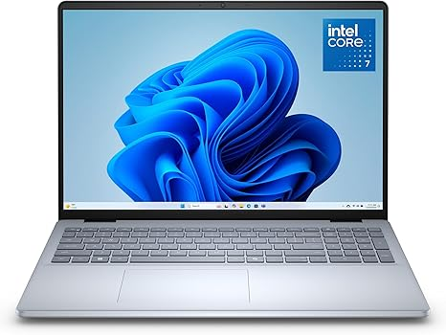
Dell 16 Laptop DC16251-16.0-inch 16:10 2K Touchscreen Display, Intel Core 7 150U Processor, 16GB DDR5 RAM, 1TB SSD, Intel Graphics, Windows 11 Home, 1 Year Basic Onsite Service, Cloud Blue
Visit the Dell Store
4.6 4.6 out of 5 stars (31)
CPU: Intel Core 7
- Intel Core 5
- AMD Ryzen AI 7
- Intel Core 7
RAM Size: 16 GB
- 16 GB
- 32 GB
Capacity: 1TB
- 1TB
- 512 GB

See available options
Style: 16.0 2K Touchscreen
- 16.0 FHD+ Non-Touch
- 16.0 FHD+ Touchscreen
- 16.0 2K Touchscreen
Brand | Dell
Model Name | Dell 16 DC16251 Laptop
Screen Size | 16 Inches
Color | Silver
Hard Disk Size | 1 TB
CPU Model | Intel Core 7
Ram Memory Installed Size | 16 GB
Operating System | Windows 11 Home
Special Feature | Anti Glare Coating, Backlit Keyboard, Fingerprint Reader, Memory Card Slot, Numeric Keypad
Graphics Card Description | Integrated
See more

About this item
- Edge-to-edge clarity: Enjoy crisp, expansive visuals on a 16-inch 2K display and a 16:10 aspect ratio—delivering a wide, immersive viewing experience.
- All-day comfort: Dell ComfortView Plus helps reduce harmful blue light emissions while preserving true-to-life color, keeping your eyes comfortable even during prolonged screen time.
- Ready for business: Flip between effortless productivity and captivating entertainment on a large, immersive screen powered by Intel Core processors and graphics.
- Built for virtual connection: Bring your connections to life with an up-to FHD camera, designed with wide dynamic range and temporal noise reduction to deliver crisp, sharp images, no matter the lighting conditions.
- Adaptive thermals: Built-in technology allows your PC to sense when it's on a stable surface and adjusts its power and thermals to run more efficiently.
https://www.amazon.com/Dell-Laptop-DC16251-16-0-inch-Touchscreen-Processor/dp/B0G8K5H16P/ref=sr_1_3?crid=2H2U5PUNFJUY9&dib=eyJ2IjoiMSJ9.UV4zu2BKNaYVcKKUMV62ofE_fG0yqnu0k3wDu6ZEGDIKE_-M3cDs89p68l0YA68AMjHDjqyfoN1scbZcWwJ8GUFxhq0V6eKRY91SonkGSdfn8zV3q5kcSWye4_WI1sdQmEU0J5XdDfKMKyKwoLtIlyjCY5dYnPHuUk12mMCRW708Tsnj89HjYr9PEOzV8J3njmGqAeNaWCWjFsep3rjyiiDDbc5lEM3dZzYLLTPXNew.GtwZR-tU7TPtRieDiJN3GvhtLEUZVyhL4k5JyVEdyeA&dib_tag=se&keywords=laptop&qid=1780385560&sprefix=laptop%2Caps%2C338&sr=8-3&th=1

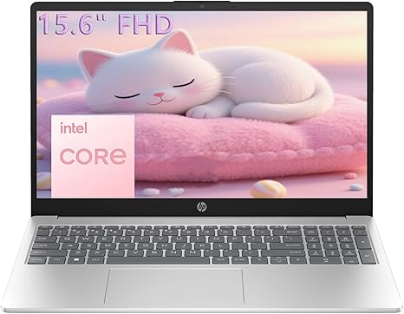
HP 15.6" FHD Laptop 2026 Edition with Copilot AI, 16GB RAM, 256GB SSD, Intel Processor, Long Battery Life, Lightweight 3.64 lbs, Microsoft 365, Windows 11 for Students & Office

This item cannot be shipped to your selected delivery location. Please choose a different delivery location.
Set name: 16GB DDR4 RAM, 256GB PCIe SSD
- 16GB DDR4 RAM, 256GB PCIe SSD

Currently unavailable.
Brand | HP
Model Name | Laptop
Screen Size | 15.6 Inches
Color | Natural Silver
Hard Disk Size | 256 GB
CPU Model | Intel Processor N100
Ram Memory Installed Size | 16 GB
Operating System | Windows 11 Home
Special Feature | HD Audio
Graphics Card Description | Integrated
See more

About this item
- Powerful Everyday Performance: Intel N100 processor with 16GB RAM handles multiple browser tabs, Microsoft Office for web, video streaming, and online classes simultaneously without slowdown. Perfect for students writing research papers while referencing sources, remote workers managing emails and video calls, or families sharing one reliable computer for homework, bills, and entertainment.
- Massive Storage Bundle: 256GB internal SSD for lightning-fast boot times and app loading. Keep schoolwork, work documents, and family memories safe with room to grow—no need to buy additional storage.
- Built for Mobility: At just 3.64 lbs, true portability lets you easily carry between classes, commute to coffee shops, or move from room to room at home. Long battery life and a quick charge keep you going through long study sessions, work marathons, or movie nights, while the 15.6" anti-glare display reduces eye strain and the slim profile fits in most backpacks and laptop bags.
- Stay Connected Anywhere: WiFi 6 technology ensures fast, stable internet for Zoom classes, video conferences, and streaming. Full-size keyboard with numeric keypad makes data entry, spreadsheets, and typing papers comfortable. Multiple USB ports, HDMI output, and headphone jack provide flexibility for external monitors, printers, and accessories.
- Complete Package, Exceptional Value: Arrives with Windows 11 Home, lifetime Office for web, and everything you need to start working or studying immediately—ready for 2026 and beyond. Ideal as a family computer, student laptop, home office workstation, or first computer, delivering reliable performance for everyday computing without premium pricing. Backed by HP quality and support.
› See more product details
https://www.amazon.com/HP-Processor-Lightweight-Microsoft-Students/dp/B0GRVFY42Q/ref=sr_1_5?crid=2H2U5PUNFJUY9&dib=eyJ2IjoiMSJ9.UV4zu2BKNaYVcKKUMV62ofE_fG0yqnu0k3wDu6ZEGDIKE_-M3cDs89p68l0YA68AMjHDjqyfoN1scbZcWwJ8GUFxhq0V6eKRY91SonkGSdfn8zV3q5kcSWye4_WI1sdQmEU0J5XdDfKMKyKwoLtIlyjCY5dYnPHuUk12mMCRW708Tsnj89HjYr9PEOzV8J3njmGqAeNaWCWjFsep3rjyiiDDbc5lEM3dZzYLLTPXNew.GtwZR-tU7TPtRieDiJN3GvhtLEUZVyhL4k5JyVEdyeA&dib_tag=se&keywords=laptop&qid=1780385560&sprefix=laptop%2Caps%2C338&sr=8-5&th=1

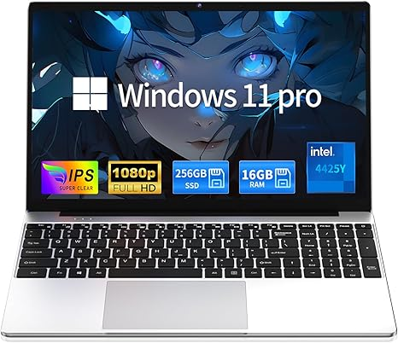

Moonfish 2026 Laptop Computer Window 11 Pro, 15.6 Inch Lap Top, 16GB RAM 256GB SSD Trational PC Notebook, Office 365, Business, School, Work, Student, Kids
Visit the MOONFISH Store
LKR 112,706.68
RAM Memory Size: 16 GB
Brand | MOONFISH
Model Name | UBOOK-03
Screen Size | 15.6 Inches
Color | Silver
Hard Disk Size | 256 GB
CPU Model | Pentium
Ram Memory Installed Size | 16 GB
Operating System | Windows 11 Pro
Special Feature | Anti Glare Coating, HD Audio, Lightweight, Memory Card Slot, Numeric Keypad
Graphics Card Description | Integrated
See more
About this item
- Ultimate Peace of Mind: 2-Year Warranty and 6-Month Free Return. Get help whenever you need it with 24/7 Online Support and weekday phone support(+1 800-606-1179).
- Powerful Performance: Equipped with the 4425Y processor, 16GB RAM and 256GB SSD. Experience lightning-fast boot-ups, quick file transfers, and seamlessly switch between multiple apps.
- Vibrant Visuals: Immerse yourself in a crisp 15.6-inch FHD (1920x1080) IPS display. Enjoy vibrant colors and a stable 60Hz refresh rate for a flawless viewing experience whether you're working, streaming, or browsing.
- Ready-to-Work out of the Box: Be productive from day one with Window 11 Pro and lifetime Office 365 pre-installed. Benefit from enhanced security features and professional-grade management tools built right in.
- Comfortable Full Keyboard:Type with comfortable thanks to the precision keyboard. The large touchpad offers smooth and comfortable control for long work sessions, web browsing, or creative projects.
- All-Day Power & Connectivity: Stay productive on the go with a long-lasting 5000mAh battery. Connect all your peripherals with versatile ports including USB 3.0, Mini HDMI, and a TF Card slot.
- Lightweight & Sleek: Crafted in a stylish silver, this ultra-portable laptop is just 0.8 inches thin and weighs a mere 3.5 lbs, making it the perfect companion for your backpack and your busy life.
› See more product details
https://www.amazon.com/Moonfish-Computer-Trational-Notebook-Business/dp/B0H2L7CKDP/ref=sxin_18_pa_sp_search_thematic_sspa?content-id=amzn1.sym.a2d8fef6-2d68-4a6a-b5d9-51823ece2f68%3Aamzn1.sym.a2d8fef6-2d68-4a6a-b5d9-51823ece2f68&crid=2H2U5PUNFJUY9&cv_ct_cx=laptop&keywords=laptop&pd_rd_i=B0H2L7CKDP&pd_rd_r=b6c468dc-ea2c-4462-a677-0c37300d2ac9&pd_rd_w=13ziT&pd_rd_wg=uTHkM&pf_rd_p=a2d8fef6-2d68-4a6a-b5d9-51823ece2f68&pf_rd_r=WCSMP5RPCDQ3K96Q67VM&qid=1780385560&sbo=RZvfv%2F%2FHxDF%2BO5021pAnSA%3D%3D&sprefix=laptop%2Caps%2C338&sr=1-1-bbb9804a-c7e9-4d92-96ec-63fab7f26c09-spons&aref=JIqVewidKC&sp_csd=d2lkZ2V0TmFtZT1zcF9zZWFyY2hfdGhlbWF0aWM&th=1

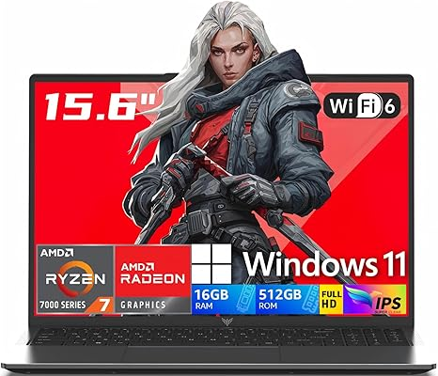

2026 AMD Gaming Laptop with Ryzen 7 5700U Processor(8C/16T, Up to 4.3GHz), AMD Radeon™ Graphics, 16GB RAM 512GB NVMe SSD, 15.6“ FHD Display Laptop with BK, WiFi 6, HDMI, Type-C, Webcam Cover Slide
Brand: KONZID
5.0 5.0 out of 5 stars (12)

LKR 179,006.68 with 68 percent savings-68% LKR179,006.68
Style: 16GB RAM | 512GB SSD
Color: Aluminum Gray
Brand | KONZID
Model Name | LX15PRO
Screen Size | 15.6 Inches
Color | Aluminum Gray
Hard Disk Size | 512 GB
CPU Model | AMD Ryzen 7
Ram Memory Installed Size | 16 GB
Operating System | Windows 11
Special Feature | Gaming laptop, Lightweight, Numeric Keypad
Graphics Card Description | Integrated
See more

About this item
- 【HIGH-PERFORMANCE AMD PROCESSOR】The KONZID Gaming Laptop, equipped with the AMD Ryzen 7 5700U (8C16T, up to 4.3GHz)processor, delivers competitive performance for all your needs. Whether you’re casual play or competitive ranks,, this laptop ensures every session is a victory. that transforms even the most processor-intensive tasks into a breeze. Tailored for professionalsand , it’s the epitome
- 【15.6" FULL HD DISPLAY】Dive into a visual feast with the KONZID Laptop expansive 15.6" (1920 x 1080) Full HD screen. Perfect for , movie, and video clip tasks, Experience the thrill of high-definition with a display designed for intense action, and savor every detail of your favorite films with colors that pop. For creators and viewers alike, this laptop offers a visual journey that captivates and delights.
- 【PORTS FOR ALL YOUR ACCESSORIES】The KONZID Gaming Laptop is outfitted with a comprehensive array of ports to cater to all your needs: a webcam, two USB 3.2 ports, HDMI, a full-function Type-C, a 3.5mm headphone/speaker/line-out jack, a TF card slot, and a Type-C DC jack. With Wi-Fi 6（up to 3x faster than Wi-Fi 5.）, you’ll enjoy blazing-fast internet speeds. The backlit keyboard doesn’t just look good—it deepens your experience, turning every session into an epic journey.
- 【MEMORY & STORAGE】The KONZID Gaming Laptop comes with 16GB DDR4 RAM and 512GB M.2 NVMe SSD, enabling you to smoothly run multiple applications and browser tabs at once. The 16GB RAM boosts performance across various applications, from multitasking to . Enjoy quick startup times and dependable storage for all your files, documents, and multimedia. The dual-channel DDR4 memory supports upgrades up to 64GB (2x32GB), and the NVMe/NGFF SSD can be upgraded up to 2TB.
- 【ALL-PURPOSE LAPTOP】KONZID laptop is pre-loaded with the Windows 11 system and features a 54.72Wh battery for up to 8 hours of battery life. Its hinge design allows for a 180° lay-flat capability. The slim profile easily slips into a backpack, and the durable metal body is built to withstand pressure. Ideal for work, online classes, or . KONZID laptops undergo a 7*24H machine test before shipment, Enjoy worry usage with a 1-year and round-the-clock customer service.
› See more product details
https://www.amazon.com/Gaming-Processor-RadeonTM-Graphics-Display/dp/B0H143K81N/ref=sr_1_9?crid=2H2U5PUNFJUY9&dib=eyJ2IjoiMSJ9.UV4zu2BKNaYVcKKUMV62ofE_fG0yqnu0k3wDu6ZEGDIKE_-M3cDs89p68l0YA68AMjHDjqyfo2026%20AMD%20Gaming%20Laptop%20with%20Ryzen%207%205700U%20Processor(8C/16T,%20Up%20to%204.3GHz),%20AMD%20Radeon%E2%84%A2%20Graphics,%2016GB%20RAM%20512GB%20NVMe%20SSD,%2015.6%E2%80%9C%20FHD%20Display%20Laptop%20with%20BK,%20WiFi%206,%20HDMI,%20Type-C,%20Webcam%20Cover%20Slide%20Brand:%20KONZID%205.0%205.0%20out%20of%205%20stars%20%20%20(12)%20LKR%20179,006.68%20with%2068%20percent%20savings-68%%20LKR179,006.68%20Typical%20price:%20LKR%20563,546.68Typical%20price:%20LKR563,546.68%20LKR%2079,762.22%20Shipping%20&%20Import%20Charges%20to%20Sri%20Lanka%20Details%20Style:%2016GB%20RAM%20|%20512GB%20SSD%20Color:%20Aluminum%20Gray%20BrandKONZID%20Model%20NameLX15PRO%20Screen%20Size15.6%20Inches%20ColorAluminum%20Gray%20Hard%20Disk%20Size512%20GB%20CPU%20ModelAMD%20Ryzen%207%20Ram%20Memory%20Installed%20Size16%20GB%20Operating%20SystemWindows%2011%20Special%20FeatureGaming%20laptop,%20Lightweight,%20Numeric%20Keypad%20Graphics%20Card%20DescriptionIntegrated%20See%20more%20About%20this%20item%20%E3%80%90HIGH-PERFORMANCE%20AMD%20PROCESSOR%E3%80%91The%20KONZID%20Gaming%20Laptop,%20equipped%20with%20the%20AMD%20Ryzen%207%205700U%20(8C16T,%20up%20to%204.3GHz)processor,%20delivers%20competitive%20performance%20for%20all%20your%20needs.%20Whether%20you%E2%80%99re%20casual%20play%20or%20competitive%20ranks,,%20this%20laptop%20ensures%20every%20session%20is%20a%20victory.%20that%20transforms%20even%20the%20most%20processor-intensive%20tasks%20into%20a%20breeze.%20Tailored%20for%20professionalsand%20,%20it%E2%80%99s%20the%20epitome%20%E3%80%9015.6%22%20FULL%20HD%20DISPLAY%E3%80%91Dive%20into%20a%20visual%20feast%20with%20the%20KONZID%20Laptop%20expansive%2015.6%22%20(1920%20x%201080)%20Full%20HD%20screen.%20Perfect%20for%20,%20movie,%20and%20video%20clip%20tasks,%20Experience%20the%20thrill%20of%20high-definition%20with%20a%20display%20designed%20for%20intense%20action,%20and%20savor%20every%20detail%20of%20your%20favorite%20films%20with%20colors%20that%20pop.%20For%20creators%20and%20viewers%20alike,%20this%20laptop%20offers%20a%20visual%20journey%20that%20captivates%20and%20delights.%20%E3%80%90PORTS%20FOR%20ALL%20YOUR%20ACCESSORIES%E3%80%91The%20KONZID%20Gaming%20Laptop%20is%20outfitted%20with%20a%20comprehensive%20array%20of%20ports%20to%20cater%20to%20all%20your%20needs:%20a%20webcam,%20two%20USB%203.2%20ports,%20HDMI,%20a%20full-function%20Type-C,%20a%203.5mm%20headphone/speaker/line-out%20jack,%20a%20TF%20card%20slot,%20and%20a%20Type-C%20DC%20jack.%20With%20Wi-Fi%206%EF%BC%88up%20to%203x%20faster%20than%20Wi-Fi%205.%EF%BC%89,%20you%E2%80%99ll%20enjoy%20blazing-fast%20internet%20speeds.%20The%20backlit%20keyboard%20doesn%E2%80%99t%20just%20look%20good%E2%80%94it%20deepens%20your%20experience,%20turning%20every%20session%20into%20an%20epic%20journey.%20%E3%80%90MEMORY%20&%20STORAGE%E3%80%91The%20KONZID%20Gaming%20Laptop%20comes%20with%2016GB%20DDR4%20RAM%20and%20512GB%20M.2%20NVMe%20SSD,%20enabling%20you%20to%20smoothly%20run%20multiple%20applications%20and%20browser%20tabs%20at%20once.%20The%2016GB%20RAM%20boosts%20performance%20across%20various%20applications,%20from%20multitasking%20to%20.%20Enjoy%20quick%20startup%20times%20and%20dependable%20storage%20for%20all%20your%20files,%20documents,%20and%20multimedia.%20The%20dual-channel%20DDR4%20memory%20supports%20upgrades%20up%20to%2064GB%20(2x32GB),%20and%20the%20NVMe/NGFF%20SSD%20can%20be%20upgraded%20up%20to%202TB.%20%E3%80%90ALL-PURPOSE%20LAPTOP%E3%80%91KONZID%20laptop%20is%20pre-loaded%20with%20the%20Windows%2011%20system%20and%20features%20a%2054.72Wh%20battery%20for%20up%20to%208%20hours%20of%20battery%20life.%20Its%20hinge%20design%20allows%20for%20a%20180%C2%B0%20lay-flat%20capability.%20The%20slim%20profile%20easily%20slips%20into%20a%20backpack,%20and%20the%20durable%20metal%20body%20is%20built%20to%20withstand%20pressure.%20Ideal%20for%20work,%20online%20classes,%20or%20.%20KONZID%20laptops%20undergo%20a%207*24H%20machine%20test%20before%20shipment,%20Enjoy%20worry%20usage%20with%20a%201-year%20and%20round-the-clock%20customer%20service.%20%E2%80%BA%20See%20more%20product%20detailsN1scbZcWwJ8GUFxhq0V6eKRY91SonkGSdfn8zV3q5kcSWye4_WI1sdQmEU0J5XdDfKMKyKwoLtIlyjCY5dYnPHuUk12mMCRW708Tsnj89HjYr9PEOzV8J3njmGqAeNaWCWjFsep3rjyiiDDbc5lEM3dZzYLLTPXNew.GtwZR-tU7TPtRieDiJN3GvhtLEUZVyhL4k5JyVEdyeA&dib_tag=se&keywords=laptop&qid=1780385560&sprefix=laptop%2Caps%2C338&sr=8-9&th=1

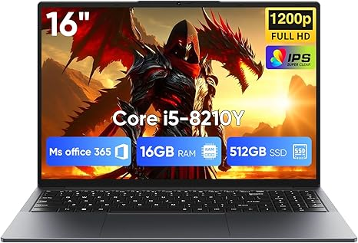
EYY 16" Laptop Computer Intel Core i5 Processor, Win 11 Pro Laptop 16GB RAM 512GB SSD, 1920 x 1200 FHD 16:10 Display, Office Suite Notebook with Backlit Keyboard, Student Business Work Laptops
Visit the EYY Store
5.0 5.0 out of 5 stars (12)

Amazon's Choice

LKR 115,690.18
Style: Upgraded
Brand | EYY
Model Name | 16" laptop
Screen Size | 16 Inches
Color | Gray
Hard Disk Size | 512 GB
CPU Model | Core i5
Ram Memory Installed Size | 16 GB
Operating System | Windows 11 Pro
Special Feature | Backlit Keyboard, HD Audio
Graphics Card Description | Integrated
See more

About this item
- [16GB RAM + 512GB SSD]This laptop features high-performance dual-channel 16GB RAM, enhancing data transfer speed to ensure smooth operation of multiple applications and browser tabs simultaneously. The 512GB SSD provides ample storage for files, applications, and media, ensuring a reliable experience for both study and work.
- [Intel Core i5-8210Y Processor]The 16-inch laptop computer is equipped with a Core i5-8210Y dual-core, four-thread processor with a maximum turbo frequency of up to 3.60GHz. It delivers smooth multitasking, runs office applications stably, improves work efficiency, and meets daily multitasking needs for work and casual entertainment.
- [16" FHD IPS Display]Win 11 Pro laptop features a 16-inch 1920 × 1200 FHD IPS display with a 16:10 aspect ratio and ultra-thin bezels. It offers a wider viewing area, clearer visuals, reducing eye viewing pressure, and a more comfortable viewing experience.
- [More features] Win 11 Pro can improve speed, security and efficiency to provide an enhanced user experience. EYY notebooks are also pre-installed and activated with office suite to meet your daily office needs.
- [Wi-Fi & Bluetooth]I5 laptop supports Wi-Fi 5 (802.11ac) and Bluetooth 5.0 for fast and stable wireless connections whether you are working from home or on the go. The 44Wh(5000mAh/7.6V) battery and backlit English keyboard help you stay productive from day to night.
- [Rich Interfaces]Equipped with a wide range of ports including 1× Micro SD card slot, 3× USB-A 3.0 ports, 1× RJ45 Ethernet port, 1× HDMI port, and 1× Type-C port (data only), making it easy to connect external devices and peripherals for efficient data transfer and presentations.
› See more product details
https://www.amazon.com/dp/B0F53V8WR5/ref=sspa_dk_detail_5?pd_rd_i=B0F53V8WR5&pd_rd_w=kfMtM&content-id=amzn1.sym.af2be12d-373e-4c68-a933-d40df60554fe&pf_rd_p=af2be12d-373e-4c68-a933-d40df60554fe&pf_rd_r=4HQFNCFFRVNEJ4H1N6CT&pd_rd_wg=b9e93&pd_rd_r=bb52ce4c-e022-45e2-b838-965c78481ce5&sp_csd=d2lkZ2V0TmFtZT1zcF9kZXRhaWxfdGhlbWF0aWM&th=1

